OCR GCE A
COMPUTER SCIENCE PROJECT
H446-03

Name : <Abdur Rahman Mohammed>
Candidate Number : <INSERT CANDIDATE NUMBER>
<Institution Name> : <48219>
Title of Project : <Sun Slayers>

H446-03 – Project CONTENTS

Table of Contents
Table of Contents 2
A. Analysis 3
Problem overview 3
stakeholders 3
how will the problem be solved using computational methods 4
Thinking abstractly 4
thinking ahead 5
Thinking Procedurally 5
Research 8
Interview with Alex walsh so i can meet the minimum requirements 8
B. Design 8
Systems diagram 8
C. Developing the coded solution (“The development story”) 8
D. Evaluation 9
Project Appendixes 10

A. Analysis

Problem overview
I am trying to replicate Mario, but I am trying to use my own ideas and imagination to create the game.
I have programmed a typical platform game where the player is gifted a sword with special abilities and powers, and they must use it to kill the underlings of their bosses. There will be 6 bosses in total and as the player defeats one boss the next will be harder. However, the player can level up and gain more skills and power. The game is scored in how long it takes them to finish the levels, this game is influenced by Mario and an Anime called demon slayer, this game will attract the gaming community because firstly, it is a spinoff of one of the most famous games that have been created and a very popular anime show which is trending right now

Whilst making my project I faced with many problems such as setting up the virtual environment because I did not know that I needed one to import Pygame that was the first problem I faced when making my code. The next problem was, my image files and turning them into animations because I made a class where they have char_type attributes so char_type _run for example this code would be given the concept of being able make the sprite run but I had to make all of the animation which took too long so the problem I faced was with efficiency so I made a variable called self.char_types = char_type_run etc then I coded the path to call the image files the actual error that came up was that this this file is not found in your directory even though it was downloaded but it was not in my actual project file. The significance of self.char.types was that it was able to store multiple animations when I called the function this made it so much simpler and easier. While making this program I have learnt how to become more efficient. My next problem was importing my enemy sprite because of file names and getting the enemy sprite to automatically go through its main animations.

stakeholders
The game is designed for anyone as it has simple game mechanics and graphics, so it is easy to understand what the stakeholder needs to do to solve the problem. This is a retro game based off Mario, so it is a fictious game so there are no real-life elements and dialogue of the characters. Therefore, the age limit to who will be able to play the game will be reduced. These features of my game will target the audience of the age 6+ as there will be death in the game but it will not be as horrifying it will just be a simple fall and then the everything restarts, it will excite the player because of the flashing animations that will be used. This game differs to how most people play games such as phones, tablets and consoles because it requires simple clicks on the mouse and 2 essential keys which make the player move.
My target audience is people around my age who enjoy platformer-style games and are interested in anime. I took this into consideration when choosing my first game tester. I opted for a fellow student who matched my criteria perfectly, therefore making him the perfect tester for my game.
I have epitomized Alex Walsh to be my games first user for the target audience. They are in my school who are interested in anime and gaming,

how will the problem be solved using computational methods
The problem can be solved by the computational method as my program is most compatible with laptop and desktop computers, so this makes more compatible to solve complex problems such as decompositions as I am implementing object orientated programming into the project. My program structure is set out straight forward as I have used many functions for each sprite and background and the movements. I have used abstraction to reduce complexity and increase efficiency with my code. My code is set a simple structure because you can hide the functions and procedures by collapsing them.

Thinking abstractly
I found out what I needed to add into my program and what I needed to remove to make my game simpler since this is what abstraction means so I can apply thinking abstractly whilst I am making my game.
I am trying to abstract sun samurai:
- Since it is a platform game it needs to be 2d so anything 3d needs to be removed
- To add functions to the background, so it does not get in the way of my character
- I need to add a storyline, so it makes It easier for the user to understand how actually play the game
- To remove sounds which have no meaning to it so it does not confuse the player
- To add a level map to indicate which level the player needs to be on to moving forward

thinking ahead
The benefit of thinking ahead is extremely vital whilst making large projects as it helps you plan, and it will save time and effort making your project. The way I would think ahead in my project would be:
- I plan to use VS code as it is widely used by many programmers, and it gives me a wide range of support
- The module which I will be using is Pygame as it is universally adaptable, and the graphics will fit the retro theme
- In my game I will add 1 main character 6 boss fights and 10 levels
- Too make my sprite importation easier I will cut my sprites animation and load them into my project file so It will be much more efficient as it will save my time by making it later
- Firstly, the main menu will be added after that the 10 levels and diving into the gameplay I will add a health by and a score system

Thinking Procedurally
Thinking procedurally will be highly beneficial as working simultaneously will be possible for example I will have a scrolling background, and this background moves when my character moves. It is somewhat like thinking ahead as it makes it more efficient and less time consuming.
This is a structure of the problem being divided

Sun Samurai

Interior of the game
Level ups
controls
Player

Experience points
Main menu
Keyboard buttons
One player game

Level menu
Mouse buttons
Settings menu

Game over

I have divided the problem into 4 main parts, thinking procedurally will be beneficial because I will be able to become more efficient as I will do more things simultaneously.
Player:
This will tell the user that there will be only one player, and their goal is to cut down any enemies coming towards them. This will give them experience which will go down to the level and the player will have to avoid getting hit by the enemy other wise their health bar will get affected
Control:
This is a very vital part of the problem so then it will allow the user to interact with the game. The keyboard buttons will allow the user to control the player by moving them and accessing their special features the mouse buttons are there for the extra attributes of the player. For example, to be able to move the player you will need to use the A and D keys.
Interior of the game:
The interior of the game will create the in-depth structure of game. Firstly, the user will be able to see the main menu where there will be two buttons on the screen labelled start and exit. Once the player clicks start, they will be able to go to the levels where there are 10 levels, the player will start at level 1 as it will give them an introduction and experience of the game. The player will have 3 lives, and each life depends on their health bar if their health bar reaches 0 it will go on their second life then if their health bar goes 0 again, they will have one life left if that life goes on 0 then they will have to restart and the sign to show that is they will see a game over screen. The settings menu will be there to lower the volume of sound effects and music volume.
Level ups:
The player will be able to collect experience points which will be used to increase their levels. When their level bar fills up then they will be able to be have access to more skills there will be a total of 10 levels.

Research

Interview with Alex walsh so i can meet the minimum requirements

what makes a good game
What game does it replicate:
Yes it does have demon slayer elements through its character and it does replicate Mario as it is a platformer game
Does the background music affect your gameplay:
Background music does not affect the gameplay but it creates an ambient environment
Do you think I should add more playable characters and add different weapons:
No because it will be easier to use just one player and one weapon
Should I add a difficulty level to make the game more competitive:
Yes because it will make the game more enjoyable
Do you think I should add a setting menu.
Yes because it will make it easier for the player to adjust to their preferences
What are your thoughts on platform games
I enjoy playing platform games because its simple

Is a selection of playable characters wanted?
Would you want each character to a have a signature move:
Yes because it will make the gameplay more enjoyable

Are more boss fights wanted
Do you think having more boss fights will make the game more interesting and enjoyable?
Yes because it gives the player an incentive to play the game
Would you want each boss to be harder to fight?
Yes because it wont be boring.

A review of the interview
This interview gave me a clear sight of how I am going to plan my game and it I know what the stakeholder wants to make the game intriguing. Me and the client thought that the sounds and animations were vital for the game play so then it will differentiate my game with Mario as it will be unique
We have agreed on background music, sound effects and flashy animations. The Stakeholder would want to the game to be simple so we will use pixel sprites. Although we want the game to be simple, we want add elements of realistic features such as adding gravity when the player jumps.
For the game interiors we have concluded that we will use a level system so this gives the player more of an enjoyable experience as there will be

Research into Super mario bros
Super Mario bros is a platformer game where the users move the player forwards to complete the game whilst they are moving forwards they are faced with obstacles and challenges once they have reached the end they are having to jump or go through a flag which marks their checkpoint and saves their current status and progress in the game. The player gets special items which allow them to upgrade and have powers; to kill the enemies, they can jump on them, or they could avoid and ignore them.
The game has levels and different worlds as they progress to the next levels, they get closer towards the final boss, each level will become more intense, and it will have different backgrounds to engage the player even more. This is

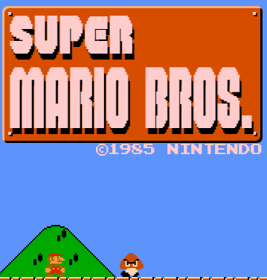
Title screen

When the game starts the player is presented with the title super Mario Bros

Gameplay
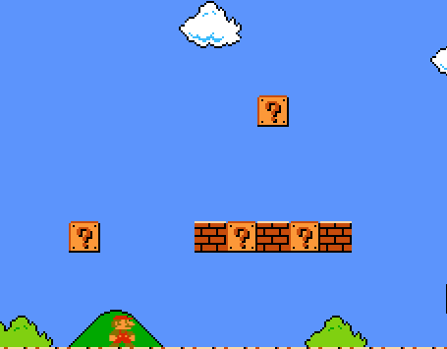
So there is a screen scroll so it continuous until it goes to the flag
Mario has to run through these blocks and he meets the enemies

time/Scoring/lives system
Score: represents how many enemies you killed it gives you 100 points per kill
Coins: this is a counter for how many coins you collect
World: this tells you which world you are in and the level
Time: the game times you in seconds and it shows how long you took to complete the level
Lives: This tells you how many lives you have and you usually start with 10

Enemies
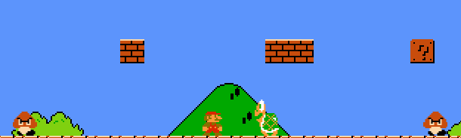
Mario has to try to avoid these enemies otherwise he will lose a life and restart at his last checkpoint. He could avoid them by jumping over but he could also jump on them.

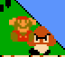
Death

This is the animation that occurs when Mario touches the enemy causing him to fall down the map and he restarts

Collectables
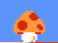

This is a lucky block which usually gives you coins but sometimes
It also gives you special mushrooms which help you grow taller
Or to give you more health

Finish line/ checkpoint
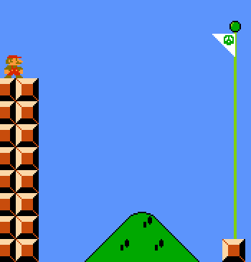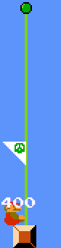
When Mario comes close to the finish he is face with a flag which he needs to jump on in order to mark his completion of that level. And in game context it shows that this area is now his territory

How do the different features effect the game play of SUper Mario
Menu:
- This is important because it allows the user to interact with the game as it allows the user to switch their world save their progress, choose which player they want to be.
Failure in the game:
- The way a player achieves failure is when they lose all their lives and at that point, they will be notified with a sound which indicates they have failed.
How are sounds used in the game:
- They are used for animations such as jumping, attacking, getting collectable items. When a player dies or when a enemy dies. And there is also background music
How are animations used in the game:
- They are used to enhance the users experience because it tries to reflect real time since they run, their arms and legs are moving and when they die they fall down slowly.

The features which will be used for my game
Question layout:
Animations/Sounds:
- What sort of animations do you want for the skeletons
- What sort of animations do you want for the fire balls
- What sort of animations do you want for the poison flower
- What are the sounds you want for effects
Game interior:
- Would you like killing the enemies hard or easy
- How would you want to lose to the game
- How would you want to win to the game
- Do you think you will enjoy killing skeletons, fireballs, and poisons flowers
- Do you want a brief description of how to play the game
- What collectable items would you like
Level:
- How many map levels would you like
- Would you want to level up the player
- Would you want the enemies to give you experience points to level up
- How many experience points would you want each enemy to give you

Interview script

Animations/Sound
What sort of animations do you want for the skeletons
- I want them to have running animations
- I want them to have attacking animations
- I want them to have death animations
What sort of animations do you want for the fireball
- I want them to have running animations
- I want them to shoot fire balls
- I want them have death animations
What sort of animations do you want for the poison flower
- I want them to have running animations
- I want them have death animations
What are the sounds you want for effects
- I would like background music
- I would like a slashing noise for the sword
- I would like a noise to alert me if I die
- I would like a noise to alert me if I win

Game interior
Would you like killing the enemies to be easy or hard
- I would like it to be hard
How would you want to die
- If I touch the enemy I lose life points or if they shoot or touch me I die
How would you want win
- By completing the levels and killing the bosses
Do you think you will enjoy killing skeletons, fireballs, and poisons flowers
- Yes because I get very nostalgic about killing skeletons, fireballs, and poisons flowers
Do you want a brief description of how to play the game
- No because the looks simple enough play
What collectable items would you like
- I would like items which give superpowers or a special move and a health booster

Level
How many map levels would you like
- 5
Would you want to level up the player
- Yes so It will be fun to play
Would you want the enemies to give you experience points to level up
- Yes so it will give me an incentive to kill the enemy
How many experience points would you want each enemy to give you
- 100 points per kill

Summary of the interview

Animations/sounds
- I want animations for each character and non-playable character
- I would like background music
- Sound affects for killing
- Sound affects for winning
- Sound affects for being killed

Game interior
- I want the game to be hard
- I want to be killed by the enemy if I touch it or it shoots me
- I want to win by killing the enemy boss
- I want collectable items

Level
- I would like 5 levels
- I want to level up my player
- I want to get 100 points per kill
- I want a score board

Game controls
- To move the players left and right: A and D keys
- To make the player jump: S key
- To make the player punch: E key
- To make the player sword jab: left mouse button
- To make the player sword slash: right mouse button
- To pause the game: P key
- To get to the menu: M key

Features of the solution
Title screen | This will be displayed when the user runs the program, and it will indicate that they are loading into the game
Main menu | This is for usability so that it can help the user interact with the game by have the option to play now
Characters | The user will be given a character who has a sword and special powers. This is done so that it can match
Enemies will be given an increase in health | This is done so that it will become challenging to kill the enemy and, in the interview, they said they wanted the game to hard
The player will be given special power fruits | This will give the player some flashy animations and it will one shot 5 enemies per use
The heart item will give the player an extra 50 health points | This is because they can continue the level without being killed and this will reduce frustration
The sound effects will be used for any movement | So when the player moves his sword there will be a sound so for every type of movement except running and jumping there will be a sound effect.
The game over screen | This will indicate that the user has completed the game or that they have to restart

B. design

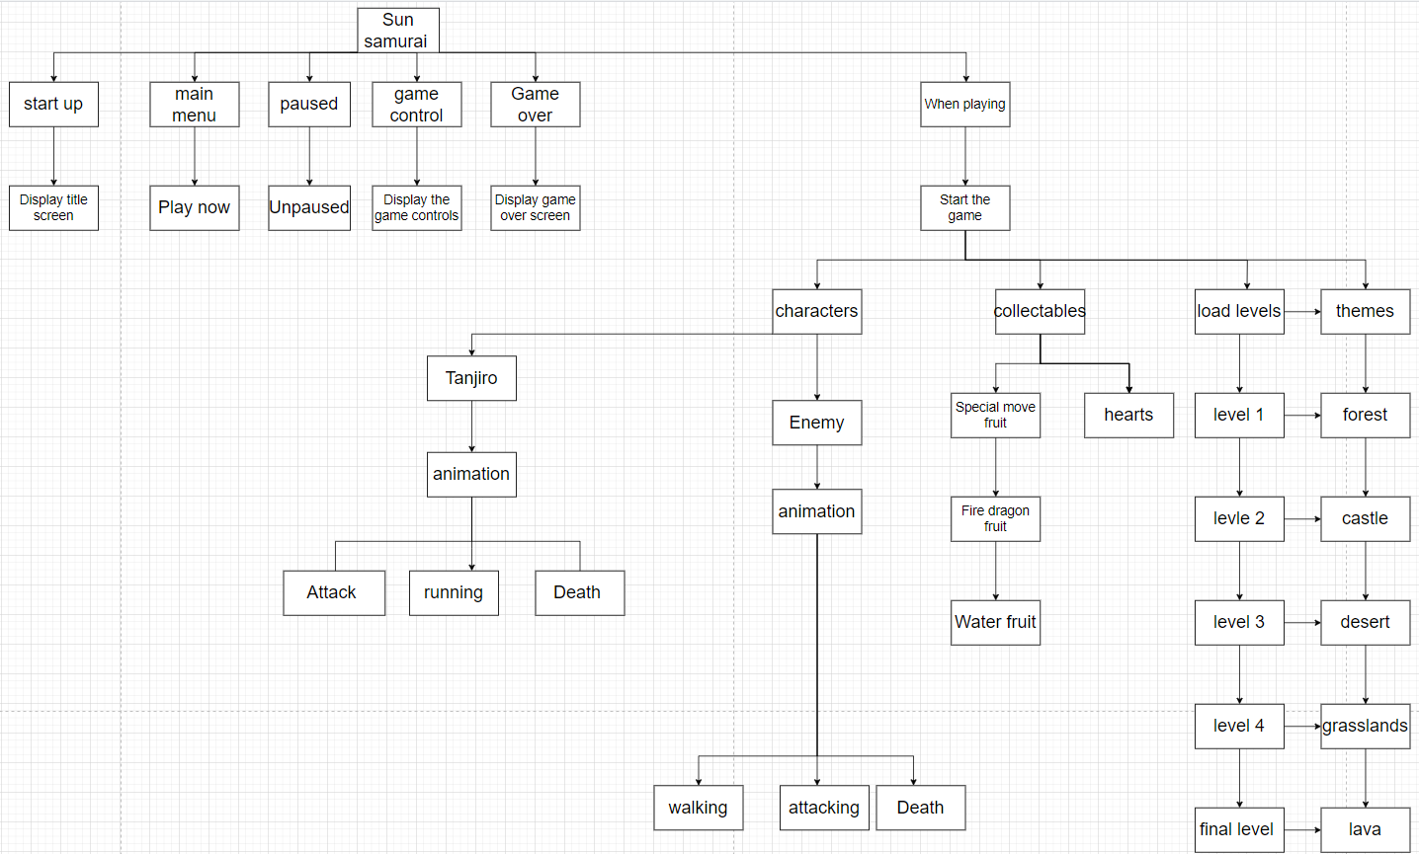

Structure diagram OF GAME states: Start up
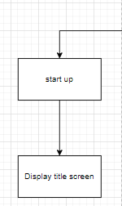
This game state helps me plan how my game will be presented, so when the game is run the player is presented with a title screen to indicate that the player is loading into the game.

Structure diagram OF GAME states: Main menu
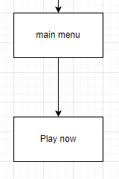
When the player is loaded into the game they are displayed with the main menu screen. In the main menu there will be one button called play now
Play now: this button is responsible for transporting the user from the main menu to the actual game

Structure diagram OF GAME states: Paused
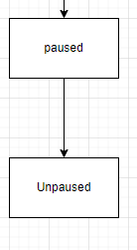
This game state is for usability so the player can interact with the game by pressing P to pause this temporarily freezes the game until the player presses the key P again

Structure diagram OF GAME states: game control
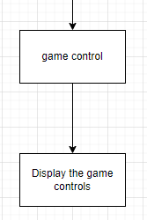
This is for displaying how to control the game

Structure diagram OF GAME states: game over
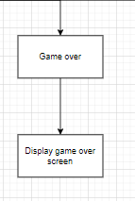
When the player either wins or loses the screen displays the image game over indicating that the player has either completed the game or needs to restart the game

Structure Diagram of game states: When playing

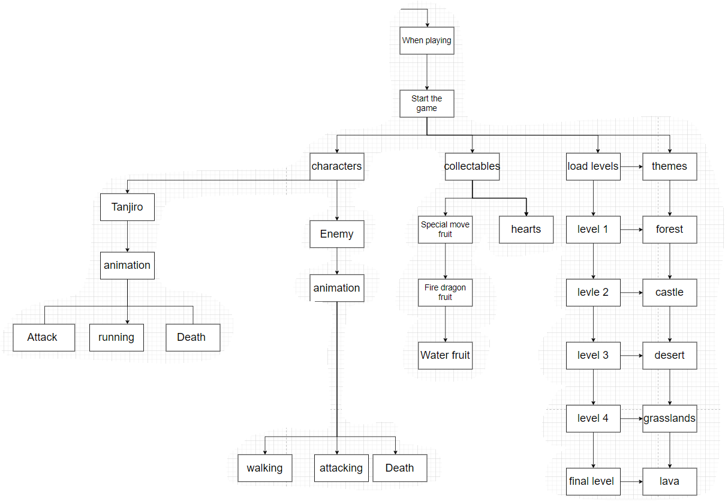

so when the player starts the game the characters, collectables, level maps are loaded into the game. First comes the level maps then once the player clicks on lets say level 1 they are teleported into the level 1 map where they start the game.
characters:
They play as the character ‘tanjiro’ who has a jumping animation, movement animation, attack animation, and death animation.
then they enemies are loaded into the game they can walk, attack and die whilst they are alive

collectables
They spawn in at random, there are currently two collectable items which are the two fruits (Red potion, blue potion) these potions give the player the ability to unlock special moves and gives full health in order to beat the level.
Load levels
this will display the level-maps in the game, there are currently 5 different levels as you progress through each level the game will get harder.
level 1:
the theme of this level is a forest so the background will be a forest, it will be easy to kill enemeis and COMPLETE LEVEL 1, the player will be obstructed by 10 enemies once they are killed the player can move on to level 2
level 2:
the theme of this level is a castle so the background will be a castle, it will get a little bit harder to kill enemies and to complete level 2, the player will be obstructed by 15 enemies. Once they are killed the player can move on to level 3
level 3:
the theme of this level is a desert so the background will be a desert, it will be harder to kill enemies and to complete level 4, the player will be obstructed by 20 enemies. Once they are killed the player can move on to level 4
level 4:
the theme of this level is a desert so the background will be a desert, it will be harder to kill enemies and to complete level 4, the player will be obstructed by 25 enemies. Once they are killed the player can move on to level 5

level 5:
the theme of this level is a desert so the background will be a desert, it will be very hard to kill enemies and to complete level 5, the player will be obstructed by 30 enemies and 1 BOSS. Once they are killed the PLAYER HAS completed the game

Usability features
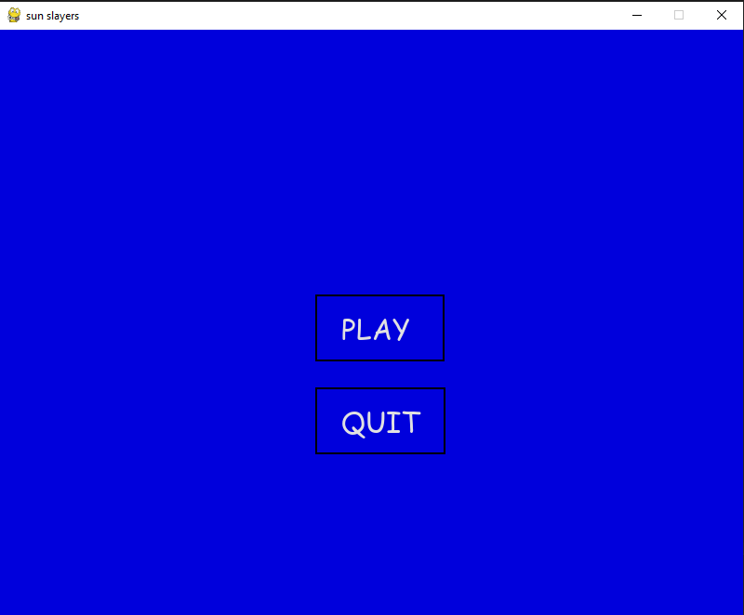
Play button:
This is used for the user interaction so that the player can get into the game, once the player has clicked the play button they will be instantly sent to level 1 to indicate that they are in level 1 it will display level 1

Quit button:
This is usability feature allows the player to quit the game and close it

Level indicator
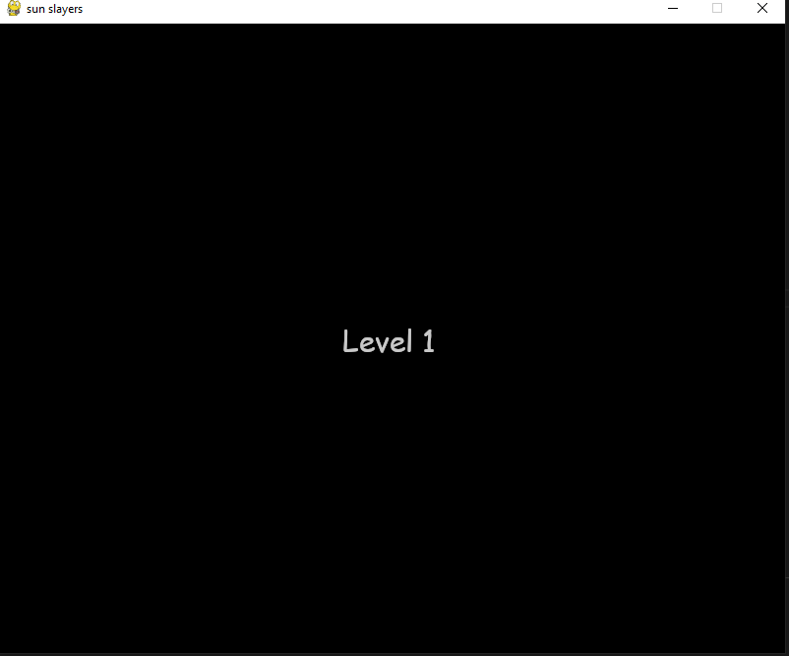
After the player has clicked the play button it will display level 1 to indicate that they are In the game successfully

Level 1
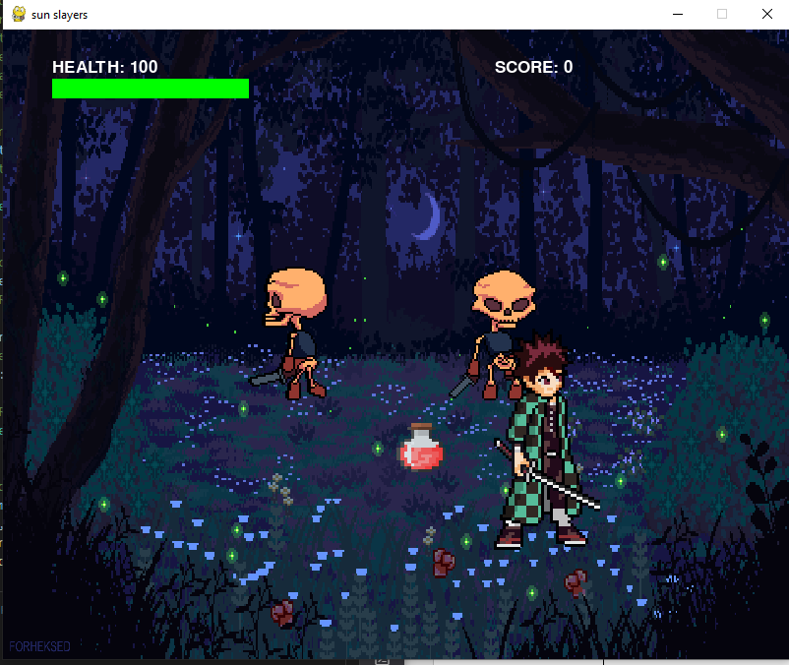

The skeletons are the enemies and the character in the green jacket and sword is the main character/player the job of the player is to kill the skeletons by using the keys e, z and x also the mouse button. I have met the criteria by making it a forest background and I have added a health bar which is functional when the player touches the enemy they lose health points

Animations of the player
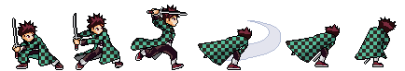

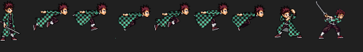

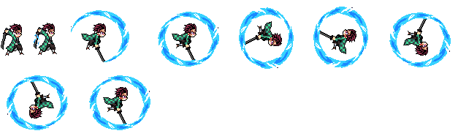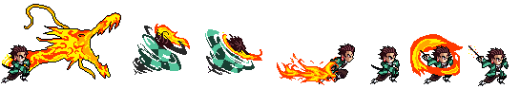
The player has a

Classes
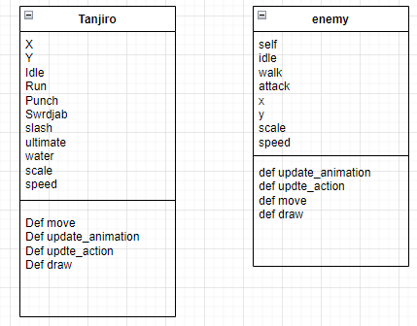

Algorithms

Method | Name | Data Type | Explanation | Justification
Game state | Mainmenu

key variables and data structures
Main menu

C. Developing the coded solution (“The development story”)

<See H446-03 Project Advice Booklet for help and guidance of what must go here.>

D. Evaluation

<See H446-03 Project Advice Booklet for help and guidance of what must go here.>

Project Appendixes
Insert as many project appendixes as you need for your project.
These might include, but are not limited to:
- Complete Code Listing (ESSENTIAL)
- Interview Transcripts
- Meeting notes
- Observation notes or questionnaires

